**MYSQL Queries and Execution screenshots:**

**-- Create the database**

**CREATE DATABASE IMDB;**

**USE IMDB;**

**-- Create Movies table**

**CREATE TABLE Movies (**

**movie_id INT AUTO_INCREMENT PRIMARY KEY,**

**title VARCHAR(255) NOT NULL,**

**release_date DATE,**

**duration INT,**

**description TEXT**

**);**

**-- Create Media table**

**CREATE TABLE Media (**

**media_id INT AUTO_INCREMENT PRIMARY KEY,**

**movie_id INT,**

**media_type ENUM('video', 'image') NOT NULL,**

**media_url VARCHAR(255) NOT NULL,**

**FOREIGN KEY (movie_id) REFERENCES Movies(movie_id)**

**);**

**-- Create Genres table**

**CREATE TABLE Genres (**

**genre_id INT AUTO_INCREMENT PRIMARY KEY,**

**genre_name VARCHAR(255) NOT NULL**

**);**

**-- Create MovieGenres table (many-to-many relationship between Movies and Genres)**

**CREATE TABLE MovieGenres (**

**movie_id INT,**

**genre_id INT,**

**PRIMARY KEY (movie_id, genre_id),**

**FOREIGN KEY (movie_id) REFERENCES Movies(movie_id),**

**FOREIGN KEY (genre_id) REFERENCES Genres(genre_id)**

**);**

**-- Create Users table**

**CREATE TABLE Users (**

**user_id INT AUTO_INCREMENT PRIMARY KEY,**

**username VARCHAR(255) NOT NULL,**

**email VARCHAR(255) NOT NULL**

**);**

**-- Create Reviews table**

**CREATE TABLE Reviews (**

**review_id INT AUTO_INCREMENT PRIMARY KEY,**

**movie_id INT,**

**user_id INT,**

**rating INT,**

**review_text TEXT,**

**FOREIGN KEY (movie_id) REFERENCES Movies(movie_id),**

**FOREIGN KEY (user_id) REFERENCES Users(user_id)**

**);**

**-- Create Artists table**

**CREATE TABLE Artists (**

**artist_id INT AUTO_INCREMENT PRIMARY KEY,**

**name VARCHAR(255) NOT NULL,**

**birth_date DATE**

**);**

**-- Create Skills table**

**CREATE TABLE Skills (**

**skill_id INT AUTO_INCREMENT PRIMARY KEY,**

**skill_name VARCHAR(255) NOT NULL**

**);**

**-- Create ArtistSkills table (many-to-many relationship between Artists and Skills)**

**CREATE TABLE ArtistSkills (**

**artist_id INT,**

**skill_id INT,**

**PRIMARY KEY (artist_id, skill_id),**

**FOREIGN KEY (artist_id) REFERENCES Artists(artist_id),**

**FOREIGN KEY (skill_id) REFERENCES Skills(skill_id)**

**);**

**-- Create Roles table**

**CREATE TABLE Roles (**

**role_id INT AUTO_INCREMENT PRIMARY KEY,**

**role_name VARCHAR(255) NOT NULL**

**);**

**-- Create MovieRoles table (many-to-many relationship between Movies and Artists with roles)**

**CREATE TABLE MovieRoles (**

**movie_id INT,**

**artist_id INT,**

**role_id INT,**

**PRIMARY KEY (movie_id, artist_id, role_id),**

**FOREIGN KEY (movie_id) REFERENCES Movies(movie_id),**

**FOREIGN KEY (artist_id) REFERENCES Artists(artist_id),**

**FOREIGN KEY (role_id) REFERENCES Roles(role_id)**

**);**

**-- Insert sample data into Movies**

**INSERT INTO Movies (title, release_date, duration, description) VALUES**

**('Inception', '2010-07-16', 148, 'A thief who steals corporate secrets through the use of dream-sharing technology.'),**

**('The Matrix', '1999-03-31', 136, 'A computer hacker learns from mysterious rebels about the true nature of his reality and his role in the war against its controllers.');**

**-- Insert sample data into Media**

**INSERT INTO Media (movie_id, media_type, media_url) VALUES**

**(1, 'video', 'http://example.com/inception_trailer.mp4'),**

**(1, 'image', 'http://example.com/inception_poster.jpg'),**

**(2, 'video', 'http://example.com/matrix_trailer.mp4'),**

**(2, 'image', 'http://example.com/matrix_poster.jpg');**

**-- Insert sample data into Genres**

**INSERT INTO Genres (genre_name) VALUES**

**('Science Fiction'),**

**('Action'),**

**('Thriller');**

**-- Insert sample data into MovieGenres**

**INSERT INTO MovieGenres (movie_id, genre_id) VALUES**

**(1, 1),**

**(1, 2),**

**(1, 3),**

**(2, 1),**

**(2, 2);**

**-- Insert sample data into Users**

**INSERT INTO Users (username, email) VALUES**

**('user1', 'user1@example.com'),**

**('user2', 'user2@example.com');**

**-- Insert sample data into Reviews**

**INSERT INTO Reviews (movie_id, user_id, rating, review_text) VALUES**

**(1, 1, 5, 'Amazing movie with a mind-bending plot!'),**

**(2, 2, 4, 'Great action and special effects.');**

**-- Insert sample data into Artists**

**INSERT INTO Artists (name, birth_date) VALUES**

**('Leonardo DiCaprio', '1974-11-11'),**

**('Keanu Reeves', '1964-09-02');**

**-- Insert sample data into Skills**

**INSERT INTO Skills (skill_name) VALUES**

**('Acting'),**

**('Directing'),**

**('Stunt Performing');**

**-- Insert sample data into ArtistSkills**

**INSERT INTO ArtistSkills (artist_id, skill_id) VALUES**

**(1, 1),**

**(2, 1),**

**(2, 3);**

**-- Insert sample data into Roles**

**INSERT INTO Roles (role_name) VALUES**

**('Lead Actor'),**

**('Supporting Actor'),**

**('Director');**

**-- Insert sample data into MovieRoles**

**INSERT INTO MovieRoles (movie_id, artist_id, role_id) VALUES**

**(1, 1, 1),**

**(2, 2, 1);**

**Execution Screen shots:**

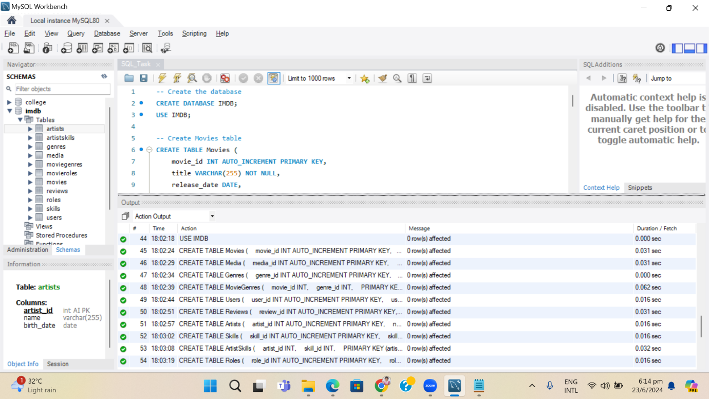

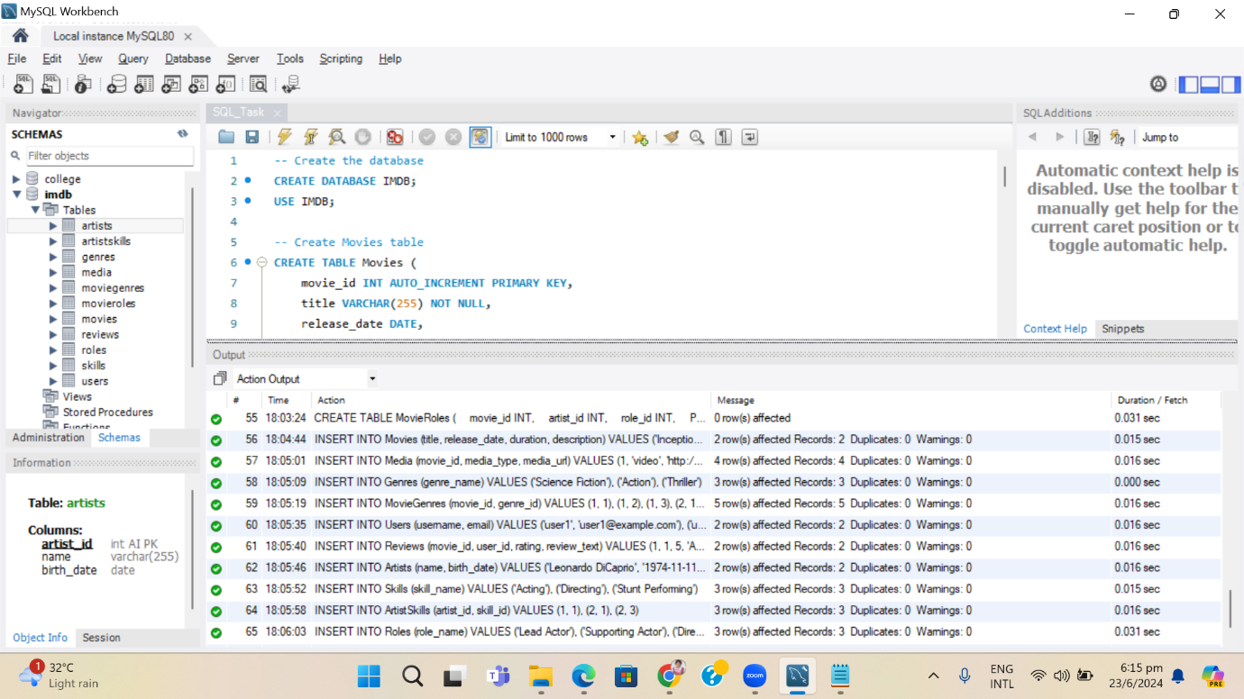

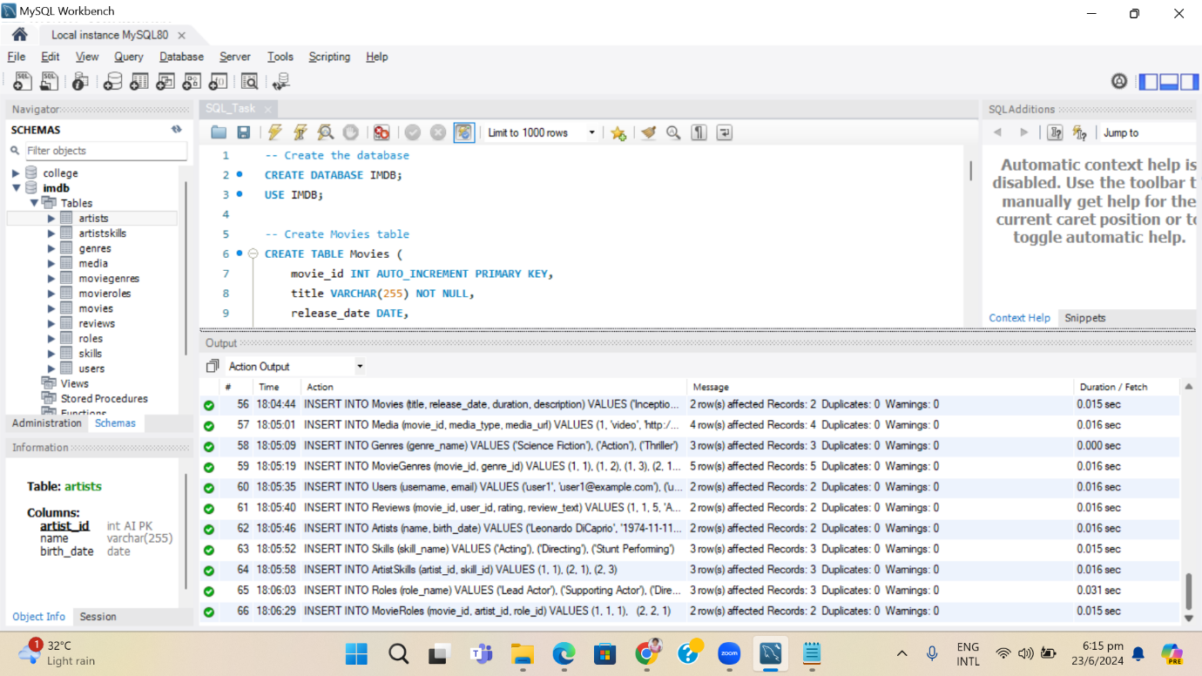

**Screenshots of Each Table:**

